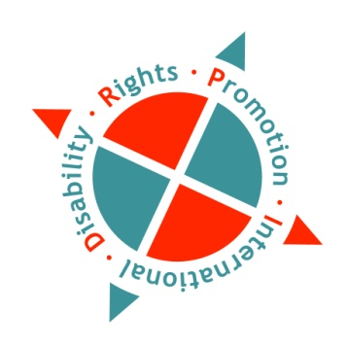
Nepal Work Placement Coordinator Position
Job Description
Full-time

There is an immediate opening for a full-time (limited term) position for Nepal Work Placement Coordinator for Disability Rights Promotion International’s Asian Workplace Approach that Respects Equality (AWARE) project.

DRPI is a collaborative project working to establish a holistic and sustainable global system to monitor the human rights of people with disabilities. DRPI is near the end of a five-year employment project, funded by Global affairs Canada. This employment project will identify and address the key labour market causes of chronic unemployment, underemployment and poverty of women and men with disabilities in three urban areas in three countries: Bangladesh (Dhaka); India (Hyderabad); and Nepal (Kathmandu). DRPI’s International Coordination Centre is based at York University in Toronto, Canada. With the support of National Federation of The Disabled - Nepal (NFDN), DRPI has established a Country Office for Nepal in Kathmandu.
The position will involve working under the direction of DRPI’s Co-Director and the project’s Principle Investigator (Marcia Rioux), DRPI’s Project Coordinator (Paula Hearn), and project partners located in Nepal.
Qualifications:
- Background in, and knowledge of, industry and employers in the Kathmandu.
- Strong networking and collaborative skills combined with an enthusiasm to build partnerships with employers across the spectrum of industries.
- Prior experience addressing workplace accommodations and adaptations
- Ability to communicate and support closely with job-seekers with their job search
- Prior experience with work placement coordination (job-matching)
- Skills to communicate and collaborate with local DPOs, employers, international partners and other stakeholders.
- Ability to work both independently and as an effective team member.
- Computer proficiency and strong administrative skills.
- Post-secondary degree in the area of Human Resources, labour relations, disability studies, or business.
- Proficiency in written and spoken English and Nepali

Preferred:
- Citizen or resident of Nepal
- Someone with background knowledge of disability rights
- Personal experience of disability and/or working with people with disabilities.
- Fluency in other languages spoken in India, Bangladesh, or Nepal is a strong asset.
Role and Responsibilities:
- Develop and maintain relationships with local employers to develop meaningful, paid employment opportunities people with disabilities.
- Will work with persons with disabilities to assist with identifying job opportunities that match their skills and work interests and facilitate a successful transition into employment.
- Will be a liaison between people with disabilities and employers
- Will provide support to company human resource departments to build inclusive workplaces, and facilitate successful workplace accommodations
- Will provide resources and collect requests from employers related to hiring and employing people with disabilities (including workplace accommodations)
- Will connect and liaise with skills training providers, disability specific skills training providers, and job search companies.
- Develop and maintain tracking and progress reports in a professional and timely manner.
Applications will be accepted until the position has been filled.
Interested candidates should submit a cover letter and their CV to the following two emails: drpi_aware@yorku.ca AND vacancy@nfdn.org.np Please indicate “APPLICATION –NEPAL WORK PLACEMENT COORDINATOR” in the subject line of the email.
For further information about this posting, please contact:
Dr. Marcia Rioux, by email: drpi_aware@yorku.ca

