
Disability Rights Promotion International

A Guide to Using NVivo to make Sense of Individual Experiences Monitoring Data

Published by Disability Rights Promotion International (DRPI)
York University
4700 Keele Street, 5021 TEL Building
Toronto, ON M3J 1P3
Canada
Telephone: +1 416 736 2100 extension: 20718
Email: drpi@yorku.ca
Website: http://www.yorku.ca/drpi/

Project Directors & Principal Investigators:
Marcia Rioux – Professor, York University, Canada
Bengt Lindqvist – Special Rapporteur on Disability (1994-2002), Sweden

Acknowledgement:
This guide draws on the contents of the publication “NVivo9: Getting Started” produced by the manufacturer of the NVivo software, QSR International, adapting the information in the QSR International publication for specific use in DRPI projects.
Written and Adapted by:
Paula Pinto – Research Associate, DRPI
Edited by:
Rita Samson – International Project Coordinator, DRPI

This publication has been financed by the Swedish International Development Cooperation Agency, Sida. Sida does not necessarily share the views expressed in this material. Responsibility for its contents rests entirely with the author.



Using NVivo to make Sense of Individual Experiences Monitoring Data
(Interviews & Focus Groups)

Objectives:

By the end of this unit, participants will:

- Understand what NVivo is and why you might want to use it.
- Use the NVivo software to organize qualitative data collected through individual experiences monitoring interviews.

- Produce reports on individual monitoring data.

1. Why use NVivo?

Monitoring the individual experiences of persons with disabilities through interviews and focus groups leads to a lot of important information being collected. Each interview and focus group is audio recorded and then fully transcribed into a computer text file. By the end of the fieldwork, Monitoring Teams have gathered hundreds of pages of very important information. The question then is - how can we make sense of all that information?

NVivo is software that helps with looking at large amounts of qualitative information and organizing it. DRPI projects use NVivo to code and organize the information from the individual experiences monitoring interviews and focus groups.

2. What is Coding?

Coding is a process in which information is sorted and categorized to help with analysis.

Instruction to Facilitator

Use slides #4 - 7 to illustrate and lead a discussion about what coding is.

3. What is the DRPI Coding Scheme?

Just like in the food examples, a Coding Scheme has been developed for DRPI projects, based on the analyses of interviews from past DRPI monitoring projects held in countries around the world. The Codes in the Coding Scheme came from studying the data collected in a number of pilot studies and it was also informed by the main objectives guiding the research. As more data was gathered, the Coding Scheme was reviewed and refined.
In addition to the socio-demographic variables, the DRPI Coding Scheme comprises five main themes:
- Human Rights Implications,
- Responses to Abuse and Discrimination,
- Reasons for Not Reporting situations of abuse and discrimination,
- Systemic Roots of Discrimination, and
- Recommendations to improve the human rights situation of persons with disabilities
- There are also three additional codes (relationships) that are used to capture information that allows the researcher to compare Disability with Gender, Ethnicity, and Class (class is simply defined as being rich or being poor).

Each of these themes and codes is organized hierarchically into sub-themes or sub-codes that resemble trees and their branches. In the language of the NVivo software, these hierarchies are called “tree nodes”.
For example, the tree node ‘Human Rights Implications’ is the one you will use to code the data that describes and illustrates Interviewees’ experiences of achievement or violation of human rights. This is the core theme of any DRPI individual monitoring project.
Take a look at the DRPI coding scheme now (see Appendix A). You already know that a tree node contains a hierarchical structure of nodes or codes. For example, the Theme, “Human Rights Implications” is divided into 8 Domains, with each domain corresponding to a particular sphere of the life of a person with a disability who has been interviewed for the study:
- Privacy and Family Life
- Education
- Work
- Social Participation
- Information and Communication
- Access to Justice
- Income Security and Support Services
- Health, Habilitation and Rehabilitation

Each Domain is then subdivided along the five human rights principles, which are the Codes:
- Dignity
- Autonomy
- Participation, Inclusion and Accessibility
- Non-Discrimination and Equality
- Respect for Difference

Each of these Codes is then subdivided into Nodes, one positive and one negative. These are the nodes that are assigned to the passages of the interviews: For example, for Autonomy in Family Life:

  - Self-Determination in Family Life (SDFAM)
  - Lack of Autonomy in Family Life (LAFAM)

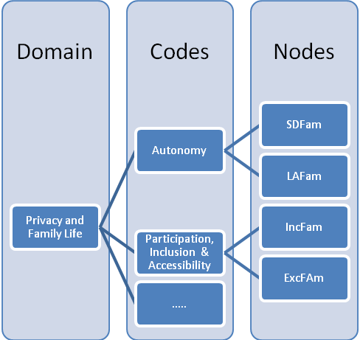

Fig.1 Example of a tree node (incomplete)

Coding Part of an Interview - Example
MONITOR 1: Did you have any trouble going to the art course?
MAN: The only problem was that the teacher was hearing and I couldn´t really grasp the communication. I couldn’t understand a lot of what the teacher was saying and I did not have an interpreter at the time.

Coding this excerpt:
The highlighted section was coded as ‘exclusion in education’, since no adequate supports were provided to this person to enable his full participation in the art class

he was taking.

The process of coding interviews can be done manually - for example, highlighting the transcript of the interview using different colours for different ideas. However, given the amount of data in DRPI projects, this would be a time-consuming task. NVivo helps with this work. The software is very easy to use. When coding in NVivo, researchers select passages of text and place these at a “node”. A node is like a category or code. Researchers can open that node to see all of the data that has been coded in that category.

It is easy to begin a DRPI project in the NVivo software. Here are the basic steps involved in:

- Creating the DRPI Project in NVivo
- Bringing in the interview transcripts into NVivo
- Creating the DRPI Coding Scheme in NVivo
- Assigning codes to the data
- Questioning the data to find patterns
- Generating Reports to present the data

Detailed information about each of these features can be found in the NVivo online help on the website: http://www.qsrinternational.com/support_contact-support.aspx

4. Working with NVivo

4.1 The NVivo Workspace
Access Help

The NVivo workspace provides easy access to all project materials.

The ribbon to locate all NVivo commands
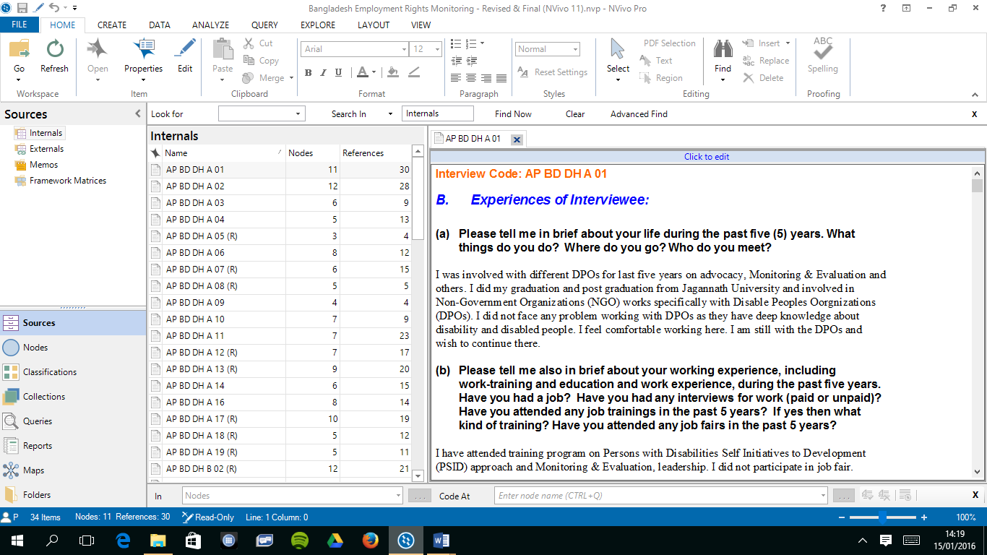
The Navigation Menu to organize materials into folders

The List View to see the content of a folder
The Detail View to work with project items
The status bar to see what is happening to the project

4.2 The ribbon
Tabs for accessing commands related to an activity
Quick access toolbar for save, edit and undo
Hover over a command to see a description

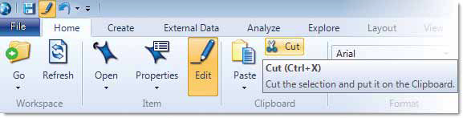

Commands are organized in groups

4.3 Navigation View

Navigation View helps organize and access all the items in NVivo. The items available in the navigation view menu that are used most often in DRPI projects are: Sources, Nodes, Classifications, Queries and Reports.

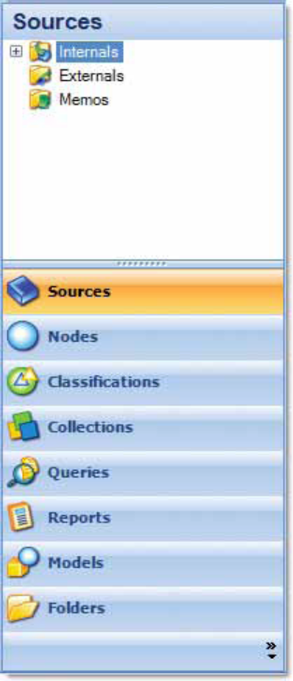
Click a button to see
all the folder on the
group
NVivo provides folders for the project materials

What are Sources?
Sources are the project materials that will be imported electronically into the DRPI file. The sources used in a DRPI project are interview and focus group transcripts and audio recordings. These are gathered as Internal Sources. Sometimes, DRPI teams also create Memos to record thoughts and observations. For instance, the Interview Notes and Focus Group Notes that monitors complete at the end of each interview and focus group can be gathered as Memos.

What are “Nodes”?
Nodes are the codes or the categories used to organize the information. DRPI has developed a coding scheme for all DRPI projects. The Coding Scheme has a set of codes that are used to analyze individual monitoring data.

The DRPI coding scheme is organized in “Tree Nodes”, that is, in hierarchical order moving from a more general category at the top (the so-called “parent node”) to more specific categories (or “child nodes”).

What are “Classifications”?
Classifications provide a way to record descriptive information about the sources and nodes. In DRPI projects, researchers use Node Classifications to provide demographic details about interviewees.

What are “Queries”?
Queries are the search criteria that can be used to question the data, find patterns and pursue ideas. DRPI projects often use matrix queries to find out how different groups (for example, men and women) differ in their human rights experiences.

What are “Reports”?
Reports are extracts of data that allow researchers to keep track of the project or make data available for use in other applications.

4.4. List View

The List View displays the content of a folder, selected from the Navigation Menu Then you can add new items, open or edit existing items.

Double click an item to open it
Drag boundary to resize columns
Sort the list by clicking on column headings

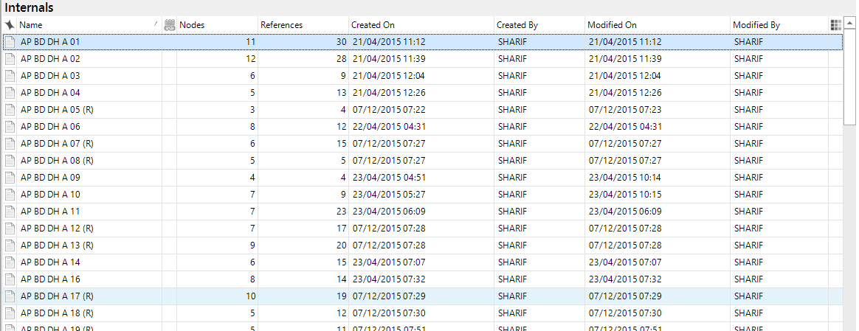

4.5 Detail View

When an interview is opened from List View, it is displayed in Detail View. The following is an example of an interview opened in Detail View:

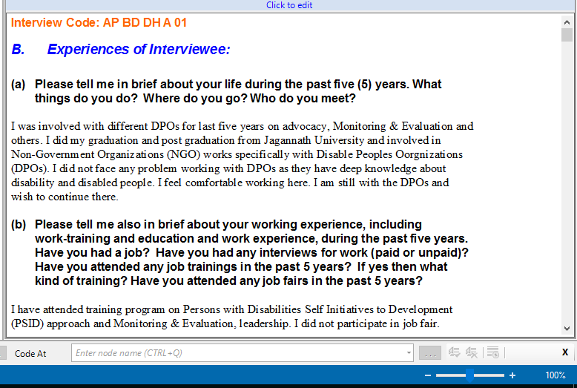

5. A step-by-step guide on how to use NVivo in a DRPI project

5.1 Uploading the NVivo software into the computer

The first thing that research teams need to do is to upload the NVivo software into the computer. Insert the CD in the appropriate drive and follow the instructions.

5.2 Creating the DRPI Project

Once the software is installed, you can create the DRPI file. The grey box below provides the instructions to create a file. When the DRPI project is stored on the computer, it is stored as an .nvp file. By default, projects are stored in the My Documents folder. Since all the project data is stored in a single file, it can easily be backed up by copying it to a new location. Backing up is always a good idea.

To create a new project:

1. Click the QSR NVivo icon on the desktop to open the application. When the application is opened for the first time, the NVivo User dialog box will be displayed.

2. By default, the Windows user name is displayed in the Name field. The name can be updated if you want. It is probably easiest to enter the researcher’s own name in this field.

3. In the Initials field, enter the researcher initials.

4. Click OK.

5. On the Welcome screen, click the New Project button. The New Project dialog box is displayed.

6. Enter the name for the project in the Title field – “DRPI (name of the country)”

7. Enter a description of the project in the Description field. For example, write: “This project is about monitoring the human rights of persons with disabilities in (name of the country)”

8. Click the Browse button on the File name box.

9. In the Save as Type list, select NVivo projects (*.nvp).

10. (Optional) change the default file location.

11. Click Save and OK.

5.3 Formatting the Sources
Before importing the interview transcripts into NVivo, it is a good idea to format the documents so that they are easier to read. For example, different Fonts and/or Colors can be used to visually distinguish between the questions asked by the Monitors and the answers provided by the Interviewee.

5.4 Bringing the Interview Transcripts into NVivo
Once the interview transcripts have been formatted, they will be brought into NVivo and organized into folders. NVivo accepts documents that are saved in text (.txt), rich text (.rtf), Word (.doc), or PDF format.

To bring interview transcripts into NVivo:

1. In the Navigation Menu, click the Internals folder.

2. On the External Data tab, click Documents. The Import Internals dialog box opens.
3. In the Import from box, click the Browse button, select the file you want to import and click open.
4. Click the More button, and under Options choose Code sources at new node:
- On the first box, select Cases.
- On the second box, under Assign new nodes to classification select Person.
- Click OK to display the Document Properties dialog box.
5. Make any changes to the name or description and click OK. The imported documents are displayed in List View and you can double-click to open it.

  - Creating Memos

Memos are imported or created in the same way as the interview transcripts—but they are stored in the Memos folder. For example a memo should be created for each interview with the Interview Notes provided by the Monitors. This information will be helpful for coding and doing the analysis.

  - Adding Annotations

Annotations are similar to scribbled notes in a margin – they allow researchers to comment on selected content in a source or node. To comment on an entire document, researchers may want to create a memo instead. In DRPI projects, researchers should use Annotations to make a brief comment on the meaning of a particular sentence that they want to review or check with the Project Coordinator later on.

To add an annotation:

1. Open the required source or node - its content is displayed in Detail View.
2. Select the content you want to annotate.
3. On the Analyze tab, in the Annotations group, click New Annotation.

4. In the Annotations tab at the bottom of Detail View, enter the annotation. The annotated text is highlighted in blue.

5.8 Creating the DRPI Coding Scheme

Since DRPI monitoring teams already know all the themes that they will be looking for in the interviews, the node structure should be created before teams start coding.

To create the DRPI coding scheme (or node structure):

1. In the Navigation View, click the Nodes button.
2. On the Create tab, click Nodes. The New Tree Node dialog box is displayed.
3. Enter the node name. For example: “Human Rights Implications”.
4. Enter a name and the description provided in the coding scheme in the Description field.
5. Click OK.
The node is added to the List View.
To add ‘children’ nodes under this node - For example, to add the ‘child node’ “Privacy and Family Life”:

1. Right click the parent node – in this case right click “Human Rights Implications”.

2. Click the New Node button and enter a name and description. Click OK. The node “Privacy and Family Life” is added under the parent node. Repeat steps 1-5 to add the five human rights principles. Then, add the positive and the negative under each of the principles.

Repeat for all other the other tree nodes in the DRPI coding scheme.

  - Adding Attributes

In DRPI individual experiences monitoring projects, information is collected about relevant attributes including sex, age group, type of disability and region where Interviewees are living. The DRPI Interview Guide also collects information about other socio-economic characteristics of the interviewees including whether or not the interviewee holds a job, who he or she lives with, as well as characteristics about his or her neighbourhood. All of this information needs to be included in the DRPI NVivo file as attributes. Later on, attributes will be used to compare the experiences of persons with disabilities according to their sex, disability type, age and region where they live.
To create classifications

1. On the Create tab, in the Classifications group, click Node Classification.
The New Classification dialog box opens.
2. Under New Classification Options, select Add one or more predefined
classifications to the project and click on the box next to Person

3. Click OK.

To add attributes and their values:
5. In the Navigation View, click Classifications, and then click Node Classifications.
6. In the List View select the classification Person

7. On the Create tab, in the Classifications group, click Attribute.
The New Attribute dialogue opens.

8. Enter a name for the attribute ─ for example, “type of disability”.

9. In the Type list, select the data type for the attribute. Choose Text if the attribute has values that are words rather than numbers or dates—for example: Gender = male, female.

10. Click the Values tab to add extra attribute values - by default, there are only two attribute values (Unassigned and Not Applicable). Click Add to create a new attribute value.
11. Click OK.
5.9. Assigning attributes to the interviews

Before starting to code, researchers should record in NVivo all of the demographic details collected for each interviewee. This is done using the classifications structure created above to assign attributes to each interview. Having demographic information in the file will allow comparison of results among different subgroups. For instance, it will be possible to see how the human rights experiences of persons with disabilities living in rural areas compare to those living in urban areas.

To assign attributes to an interview:

- In the Navigation View, click on Nodes and select Cases.
- In the List View, click on the first interview. On the Home tab, click on Properties and then select Node Properties. A dialog box opens.
- Select the Attribute Values tab. A new dialogue box opens. Click on the arrows on the right to choose the appropriate value for each attribute.
- Click Apply. Click OK.

6. Organizing and working with data
The process of organizing data by assigning codes is called coding. During the coding process, at least two independent coders should work on the same interview. Ideally, one of the coders should be from a community partner organization. Each of the two coders codes the interview independently. Afterward, they compare their results to see if they have coded in a similar way. They can discuss the way they have coded and ways that they can be more consistent when coding the rest of the interviews. Although coding is done only on the content of the interviews, the Interview Notes taken by the Monitors (which should be imported into NVivo as memos) are very important and should be taken into consideration. These Interview Notes provide valuable information for coders and can help to clarify the meaning and context of the stories collected.

6.1 What you need to know about coding:

- Coding individual monitoring interviews and focus groups is not like coding other types of data. Although some of the technical procedures are similar to those you would use in other research projects, in this case, it is the content that matters most. In qualitative studies like this one, coding is about interpreting and making sense of raw data by organizing the data according to key themes and concepts. This process requires knowledge and understanding of the conceptual framework that DRPI uses in its work – that is, a human rights approach to disability. Even experienced researchers need to become familiar with this conceptual framework before beginning to code. Strong understanding of the rights-based approach to disability is crucial in this work because coding involves framing the stories gathered from a human rights perspective to show how people experience exercise or denial of fundamental rights in their daily lives. Frequently during the analysis process, coders will have to look for what is behind the attitudes, behaviours or situations that interviewees are describing so that they will be to properly classify them in human rights terms. If that is not done consistently, the information coming out of the monitoring study will not be detailed and will not contribute to advancing the human rights situation of persons with disabilities.

Each coder also needs to become familiar with the DRPI coding scheme and understand its hierarchical structure. Note that only the codes and sub-codes that are in bold font are used.

IMPORTANT TIP: As you assign codes to the interviews, think about the stories that are told in terms of exercise or denial of human rights. Your analysis should highlight the barriers (whether these are visible or more systemic) that persons with disabilities face when trying to access their rights.

Assigning Codes - Example
Read the following excerpt:
“MONITOR 1: Well, how does it make you feel when the waitress can’t just ask you what you want like she does everybody else? How does that affect you?
WOMAN: Well as I mentioned not, not an equal.” (DRPI TO, DTB09-19-08-2008)

Coding this excerpt:
- The first thing you need to decide is the theme being addressed in this excerpt. The story being told has clear human rights implications for the subject, so the correct theme is Human Rights Implications.
- Then you need to assign a domain. The situation takes place in a restaurant, so the appropriate domain is Social Participation.
- Finally, the human right principle at stake is non-discrimination and equality. Since the story involves a violation of this principle, the right code to assign is D&INEQPART.

- Before starting to assign codes, read through the whole interview once to get a comprehensive understanding of the story or stories the Interviewee has told. Do not start coding until you are reading the interview for the 2nd time.

- When you start coding, read each phrase, sentence or paragraph very carefully and ask yourself the questions: “what is this about?”, “what is going on here?” “ Why is this being done?”. This way, you will understand the underlying meaning of the data and determine which code(s) to assign.

To code at an existing node:

1. Open the source you want to code - it is displayed in Detail View.
2. Open the required node folder to display the nodes in List View.
3. Select the source content you want to code and drag it to the required node.
4. The content is coded at the node. If you open the node (by double-clicking on it) you can see coded content.

- When coding, keep in mind the following:
  - Partial sentences, a whole sentence or even an entire paragraph (or more than one) can be coded under one code.

More than one paragraph coded with the same code – Example:
“MAN - I was in a hospital complex continuing care unit in Sudbury... and they had just changed their criteria for staying there. I had to leave no matter what so, the first bed opening down here I had to take it and this was it. This is not... if I had known...about other places... that exist... I would have probably forced them to wait... so I could move into another place that’s...geared income... and when I have my own apartment.
MONITOR 1: So did you feel pressured to make the decision that you made?
MAN: Yes definitely.
MONITOR 1: Ok and what made you feel that way?
MAN: I felt like I was being rushed out the door.” (DRPI TO, 18-06-2008-interview15)

Coding this excerpt:
All paragraphs in this excerpt were coded as Lack of Autonomy in Social Participation (LAPART)

- A partial sentence coded:
WOMAN – (…)They gave us... a ride even though we had not booked...any ride but then on a different occasion they.... get you a ride one way but they won’t... give you the ride you want back... like for example, today they got me here way earlier than I needed to be here but situations like that with Wheeltrans you can’t control. (DRPI TO, 18-06-2008-interview16)

Coding this excerpt:
Only the highlighted section of the sentence in this excerpt was coded as Lack of Autonomy in Social Participation (LAPART)

□ The same passage (whether it is a partial sentence, a whole sentence or a paragraph) can be coded under more than one code. This should not happen all the time, but it will be the right option at least in two cases:

Part of Interview is Coded Under More than One Node - Example

MAN - …I felt I was being rushed out the door.
Monitor - Why do you think people treat you that way?
MAN - It was a funding issue (DRPI TO, 16-06-2008-interview15)

Coding this excerpt:
This excerpt was coded in the theme HUMAN RIGHTS IMPLICATIONS under the code LACK OF AUTONOMY IN SOCIAL PARTICIPATION (LAPART). In addition, as the situation described refers to systemic discrimination it was also coded as SYSTEMIC ROOTS OF DISCRIMINATION – ECONOMIC.

Example

MAN - …There are public announcements that definitely should be captioned and things that I need to pay attention and that irks me. Political campaigns are one of them. The progressive conservative on the last provincial election didn’t have captioning at all, ... (DRPI TO, DTA15-28-08-2008)

Coding this excerpt:
This excerpt was coded in the theme HUMAN RIGHTS IMPLICATIONS, under two domains - INFORMATION & COMMUNICATION and SOCIAL PARTICIPATION, since the situation described involves issues of communication in relation to political participation. The codes assigned were D&INEQINF and D&INEQPART

- It is not necessary to code every sentence or word from the interview. There will be partial sentences, whole sentences and even entire paragraphs that will not be coded at all. This will happen whenever these sections address topics that are not particularly relevant to the purposes of the DRPI project.

Part of Interview is Not Coded At All - Example

“MONITOR 1: So were wondering if you could tell us about yourself in the last 5 years. Sort of what things do you do, where do you go, just a general overall –and then we’ll go more specific?
WOMAN: Um for the past 5 years—I found out 5 years ago that I have scoliosis which is a curvature of the spine…” (DRPI TO, DBT22-2008-09-30)

Excerpt not coded

These sentences in the beginning of an interview were not coded at all.

- In case an Interviewee gives contradictory information in the process of the interview, these sections should not be coded but an annotation can be made so that the coder discusses it later with the rest of the data analysis team.
Contradictory Information - Example

A typical example of contradiction is when the Interviewee states that she/he feels they have been respected, but the situation being described indicates exactly the opposite, as in the following excerpt:

“MONITOR 1: Do you recall a particular time or event when you were left out or treated badly?
Respondent: I don’t have experience like that.
MONITOR 1: Your experiences about discrimination, for example, were you ever labeled, or taunted. Tell us about your unpleasant experiences, like when your human rights have not been respected.
Respondent: They would imitate the way I talk”. (DRPI Philippines, PLC10)

- If the Interviewee provides information that does not necessarily fit into the existing coding scheme the coder should consider whether a new code is needed; in any case, the coder should create a memo and discuss it with the data analysis team and the Project Coordinator.
- Coders should never presume they know what the Interviewee means. If a statement is unclear or ambiguous, set it aside. As the interview progresses, the statement may become more explicable and can then be coded (possibly with the aid of a comment to enhance clarity of statement in a concise fashion).
- A third, sometimes even a fourth reading of an interview may be necessary. For example, it is important to read the interviews several times and with a critical eye in order to identify systemic roots of discrimination.
- Recall as was mentioned above, to ensure that the coding is reliable, at least two independent coders should work on coding the same interview. Ideally, one of the coders should be from a community partner organization. Coding should be done independently by each of them and then results should be compared and discussed until an agreement is reached.

Exercises – Practising Coding

Using the DRPI coding scheme, code the following excerpts from interviews:
#1.
M: How is the disability you have a reason for the government officials or society to treat you like this, like not giving you a job?
I: As they are sending us out and away without giving us a job, I feel strongly that it is our disability that is the reason. For example, I could not write the exam of the Railway Recruitment Board as I would not be able to move about and do the job of a Ticket Collector. But the fact also remains that I am in all ways qualified to both write the exam and pass it. The Government and the government officials are under a strong impression that there are some jobs that the disabled people cannot do at all. They say, you are handicapped that is why you cannot work nor do any job. No one says, you are intelligent and are well educated, most definitely you can do any work or job. That is why I am saying that disability is most surely one of the main reasons why we do not get any employment. (DRPI India, ICE-01)

#2
WOMAN: If they [the adapted transportation] are late by an hour and I’m waiting or even if the ride is excessively long, the next day I can’t move, I have to lay in bed, I have to sleep in the afternoon, my body aches, I have pain everywhere, it’s just not worth the trouble. And I find there’s another dichotomy here, that’s kind of, it’s ironic. If I use the scooter, cause I can walk, if I use the scooter, I end up waiting, usually waiting because buses are always late. (DRPI TO, DTB08-16-08-2008)

6.2 Displaying Coding Stripes

Coding stripes let researchers see the nodes or codes that have been used to code an interview. Researchers can also highlight the transcript to check what they have and have not coded.

To display coding stripes:

1. Open the interview.
2. On the View tab, click Coding Stripes. (alternatively, you can click on Highlight)
3. Click Nodes Most Coding or Nodes Recently Coding. The selected coding stripes are displayed.
6.3 Exploring a Node

When a node is opened, researchers can see all of the information that has been coded at that node. This is a great tool to search for good quotes to illustrate the final report.

To open a node:

1. In Navigation View, click the Nodes button.
2. Click the required node folder. The nodes are displayed in List View.
3. Double-click the required node. The node is provided in Detail View.

6.4 Questioning the Data

When all of the interviews are coded, researchers can start querying or questioning the data. This section of the guide provides an introduction to this activity. For more detailed instructions, please refer to the NVivo online help.
In DRPI projects, Matrix Coding queries are created (and saved) to explore differences in access to human rights across subgroups constituted by sex, type of disability, region and age group. The result is displayed in a table or matrix.

To create a matrix query:
1. On the Explore tab, click New Query, and then click Matrix Coding. The Matrix Coding Query dialog box opens.
2. On the Rows tab, define the rows of the Matrix:

- In the Define More Rows list, click the type of item you want to display in rows – click the Select button to select the appropriate item from Tree Nodes.

- Click the Add to List button. The item is added to the matrix box.

3. On the Columns tab, define the columns of the matrix:

- In the Define More Columns list, click the type of item you want to display in rows – click the Select button to select the appropriate item from Nodes Classifications.

- Click the Add to List button. The item is added to the matrix box.

- Click Run

Refer to the NVivo online help for detailed information about setting up and running this type of query - the ‘Working With Your Data' section of the online help provides tips, strategies and examples for working with queries.

- Finally some Results: How to get reports in NVivo

NVivo can produce various reports that enable researchers to check the progress and results of their project. The ones most used in DRPI projects are:

- Project Summary - A list of the project status in terms of the items it contains (nodes, attributes, cases). This can be useful for communicating or recording the overall progress of your project.

- Node Summary - A list of the nodes in the project, including the number of sources coded at each node. This can help you to see which themes or ideas are occurring most often.

- Attribute Summary - A list of attributes and the number of cases assigned to each attribute value. This is a useful way of checking for consistency and balance in the project sample.

To run a report:
1. In the Navigation List, click Reports.
2. On the Explore tab, select New Report.
3. Select the option From a View and then use the arrow to choose the appropriate report. Click on Next.
4. Select from the list the fields you want to report on and then follow the wizard.
In the end click on Finish. The report is saved and displayed in the Detail View.

8. Writing a Country Report about Individual Experiences:

Once the interviews have been analysed, a report has to be written. This report will focus on the individual human rights experiences of persons with disabilities in the country. This will form part of the Country Monitoring Report which will also include information from Systemic Monitoring and Media Monitoring. Examples of reports about individual experiences monitoring from completed DRPI projects can be found on the DRPI website at http://www.yorku.ca/drpi/.

The report should be written in a clear, accessible language, avoiding jargon and terms that are disrespectful to the dignity of persons with disabilities. Any acronyms or abbreviations should be clearly defined at the outset and should generally not be used. (for example, calling persons with disabilities PWDs is considered disrespectful by many people so it should be avoided)

To facilitate international comparisons, DRPI suggests the following format for this report:

A. Description of socio-demographic characteristics of the people interviewed;
B. Descriptive analysis of data;
C. Relational analysis of data;
D. Conclusions and recommendations coming out of individual experiences
monitoring information

Here are some tips on what to include in each of these sections:

A. Socio-demographic characteristics:
This section will provide information on the socio-demographic indicators of the group of people who were interviewed (that is, the “sample”). These socio-demographic indicators are age, sex, type of disability, and other relevant socio-demographic characteristics that have been included in the questionnaire.

It may be useful to present the socio-demographic data in a table. For each indicator, include a column for absolute values (the real number of persons interviewed) and another for relative values (those numbers calculated as percentages).

Example of a socio-demographic table
Socio-demographic indicators | Absolute Values | Percentage
Sex  Male  Female | 35  45 | 44%  56%
Type of Impairment  Mobility  Sensorial – Blind  Sensorial – Deaf  Intellectual  Mental Illness  Other | 22  17  18  12  10  1 | 27%  21%  23%  15%  13%  1%
….

In the text that accompanies the table, highlight the most significant values and comment on whether your sample was balanced or not. If the sample is skewed towards one or several dimensions discuss the reasons why.

B. Descriptive analysis

The purpose of this section is to provide an overview of the results obtained when the interviews and focus groups were coded. Both quantitative and qualitative data is presented.

Quantitative data involves counting the number of interviewees whose reports have been coded under each category. Quantitative data is usually presented in tables in order to provide a snapshot of the study outcomes.

Qualitative data are the quotes from interviewees and focus group participants that are selected to illustrate the information in the quantitative tables. Qualitative data give people who are reading the report a sense of the human rights issues facing the persons with disabilities who were interviewed or who participated in focus groups.

Here are guidelines for writing this section of the report:
- To be clear, quantitative data related to each code should be presented in a separate table. In each table, include a column for “absolute number of sources coded” and another column for relative values (percentages).

Example of a Descriptive Analysis Table
Human Rights in Social Participation
Human Rights Principle | Number of Sources coded | Percentages
Autonomy  Self-determination  Lack of Autonomy | 23  38 | 22%  18%
Dignity  Dignity  Lack of dignity | 12  38 | 12%  37%
…

- Insert a note to explain what the column titles “number of sources coded” and “percentages” mean. “Number of sources coded” means the number of Interviewees that offered comments on a particular code/theme, even if they produced more than one comment. “Percentages” refers to the percentage of the total number of coded interviews that offered comments on a particular code/theme.
- In the paragraphs that accompany each table, start by providing the definition of each code/variable under analysis. (You can use the definitions provided in the coding scheme).
- Also in these paragraphs, do not just describe the values that are found in the table. Instead, comment on the range of situations/reports that have been coded under each variable/ category. This is important because the reader does not have access to that information.
- Insert quotations to illustrate the points you are making. To avoid ending up with a very long report, you can use some parts of the quotation and omit others that are not as relevant to the point you are trying to make. When you leave out portions of a quotation, indicate that by using (…) in the place where you have taken out words. You can also take just bits of a sentence or only an expression or word from an Interviewee, if they are very expressive, and include them in your own text, when you are making your comments. Remember to use quotation marks to signify that the expressions/words came from the Interviewees.

Description Quotations - EXAMPLE

“As demonstrated in the table above, with respect to the social participation of persons with disabilities, the study shows that 44% of interviewees reported feeling isolation and lack of accessibility in the social sphere (…). Interviewees were prevented from having a social life due to the discrimination they experience. One Interviewee disclosed:

I had problems where I used to live, it wasn’t accessible for me to get out or to go anywhere, so I stayed inside the house.

And another shared:

Often doors are closed for all blind people and it is very difficult to get in amongst all the normal people.”

(Adapted from DRPI Bolivia country report)

IMPORTANT TIP: Adopt a human rights perspective as a data analyst. Your analysis should illuminate critical questions and issues beyond what is presented by the interviewees.

C. Relational Analysis
The purpose of this section is to explore relationships between variables (or nodes). Results are obtained using the Matrix Coding Queries tool in NVivo. The following are the queries that should be explored:

To compare results between males and females, examine the following query:
- Human Rights Implications (each individually) by gender.

To compare results across regions (or monitoring sites) examine the query:
- Human Rights Implications (each individually) by region

To compare results across types of disability examine the query:
- Human Rights Implications (each individually) by type of disability

To compare results across age ranks examine the queries:
- Human Rights Implications (each individually) by age rank

Guidelines for writing this section of the report:

- For this section of the report to be easy to read, quantitative data relating to each query under analysis should be presented in a cross-table. Since comparisons will be made among groups across indicators, in addition to a column presenting the number of sources coded, the table should also include Row and Column percentages:

  - Row percentages are calculated on the basis of the row total. They let us to make comparisons across groups (for example, compare the experiences of men and women in a particular node – social participation, or education, etc.).
  - Column percentages are calculated on the basis of the column total. They let us to compare the distribution among categories of variables within each group (for example, compare how the experiences of the age group 18-25 relative to different types of attitudes).

EXAMPLE of RELATIONAL ANALYSIS TABLE
Social Participation by Sex
 | Male |  |  | Female |  |  | Row Total
 | Sources Coded | Row Percent. | Column Percent. | Sources Coded | Row Percent. | Column Percent. | Row Total
Autonomy  Self-determination  Lack of Autonomy | 13  12 | 56%  66% | 37%  34% | 10  6 | 43%  33% | 22%  13% | 23  18
Dignity  Dignity  Lack of dignity | 9  23 | 75%  61% | 26%  66% | 3  15 | 25%  39% | 7%  33% | 12  38
…..
Column Total | 35 |  |  | 45

2. Be careful with the interpretation of the statistics. If the different groups being compared do not have the same size (for example, if the sample has more people in the age bracket 25-40 than in the age bracket 70+) the row percentages will reflect that fact and we will find more reports from people aged 25-40 than from people aged 70+. The column percentages will also be skewed ( for example, if the group 70+ is very small with only 3 Interviewees and they all happen to be coded in the same category, this will provide a 100% column percentage for that variable in that specific age group). You must acknowledge these problems as you comment on your tables.

- When the results presented in this section are discussed in the text, it is very important to reflect on the particularities of local/national politics and contexts. The participation of representatives from organizations of persons with disabilities at this stage is very important. Their specific knowledge of disability issues and the barriers facing persons with disabilities in the county is extremely useful for critical analysis and interpretation.

- Here are the steps you may follow when discussing the data presented on the cross-tables:
(a) Compare the groups among themselves (carefully using the statistics
from the row percentages)
(b) Explain/interpret the differences found (using hypotheses if you cannot test your assertions)
(c) Analyse each of the groups, or the most significant ones (carefully using the statistics from the column percentages)
(d) Explain/interpret differences.

DISCUSSION ON RELATIONAL ANALYSES - EXAMPLE

“The group most vulnerable to isolation and exclusion from social, recreational and cultural activities are males between 36 and 50 years of age. This group reports not being respected and valued in their social environment due to the fact that they are often considered a burden for society.

In general, and across all age groups, more males than females report feeling excluded and treated unequally in the social sphere. It should be noted, however, that there is an unequal distribution of the study sample in terms of sex, that is skewed towards men.”
(Adapted from DRPI Bolivia Country Report)

4) Conclusion and Recommendations
The report should conclude with a summary of the main findings of the research. It is very important that this section reflects the critical work that has been done in coding and analysing the data. The conclusions typically are organized around three or four topics that have clear implications for future policy and advocacy work from a human rights perspective. Since these findings have been described in detail elsewhere in the report, in the concluding remarks it is only necessary to review them briefly. This section of the report usually is no longer that 1 or 2 pages.

After summarizing the key findings of the study, the report should present a number of policy recommendations that address the main human rights issues affecting persons with disabilities in the country where the monitoring study was completed. The recommendations should discuss policy initiatives that, if implemented, would bring about a real change in the economic and social situation of persons with disabilities living in that country.

Coding a DRPI Project Using NVivo

Here are the 5 steps typically involved in a DRPI project using NVivo:

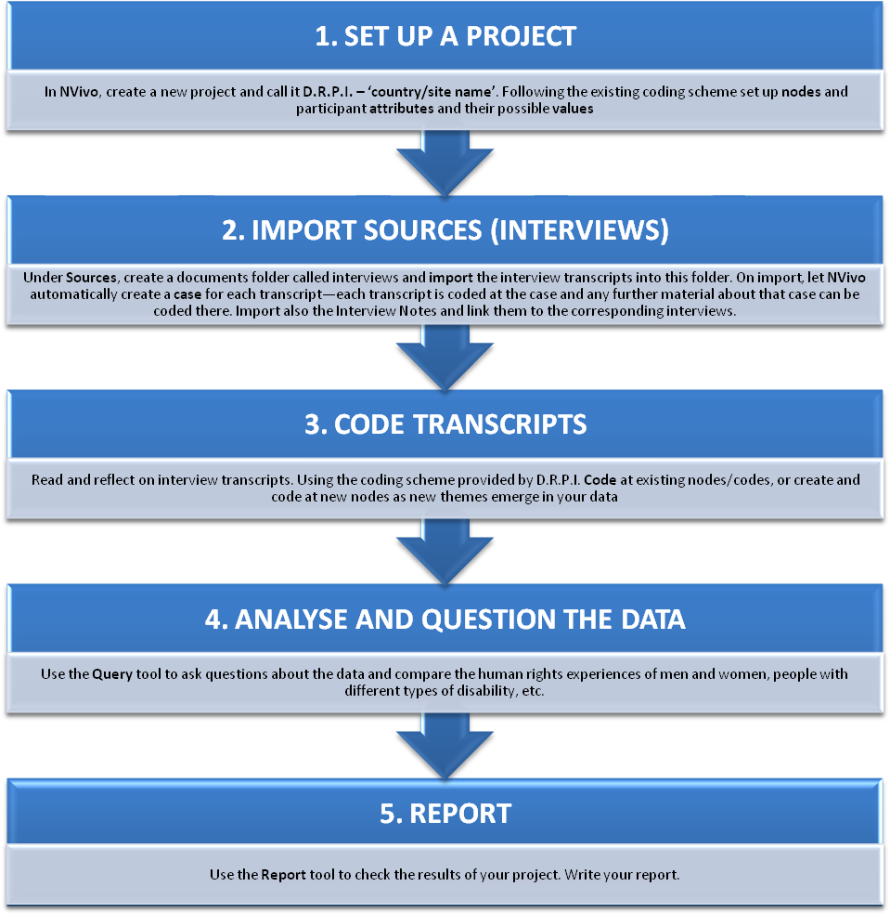

NVivo also lets you import an attribute table or spreadsheet - refer to the NVivo online help for information about how to do this.
In this case, ”reports” refer to summaries of data that can be obtained from NVivo. This is different from “reporting” which is one of the final steps in the monitoring process.

